Find the total area covered by two **rectilinear** rectangles in a **2D** plane.

Each rectangle is defined by its bottom left corner and top right corner as shown in the figure.

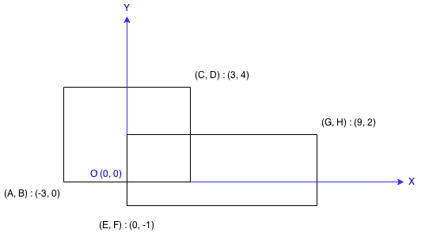

**Example:**

**Input:** A = -3, B = 0, C = 3, D = 4, E = 0, F = -1, G = 9, H = 2

**Output:** 45

**Note:**

Assume that the total area is never beyond the maximum possible value of **int**.